**EOL Design Document**

Lucid Motors Inverter Production Test

Revision History

|  |  |  |  |
| --- | --- | --- | --- |
| **Date** | **Version** | **Author** | **Comment** |
| 9/22/2020 | 3 | Rambabu Surada | Entered expected DSA flash process |
| 9/22/2020 | 2.1 | Shan Gao | Reduce overall EOL time |
| 9/21/2020 | 2.0 | Rambabu Surada | Revision-2 |
| 9/15/2020 | 1.0 | Rambabu Surada | Revision-1, first draft |
|  |  |  |  |
|  |  |  |  |

Changes

V2: Added flashing block diagram per DSA request.

V2.1: Reduce the duration of 350A/166Hz (Step 9.6) from 300s to 200s

Switched the sender and receiver of Step 7.5

# Purpose

This document describes the test sequence procedure that needs to be performed on Inverter EOL station.

# Test Station Summary

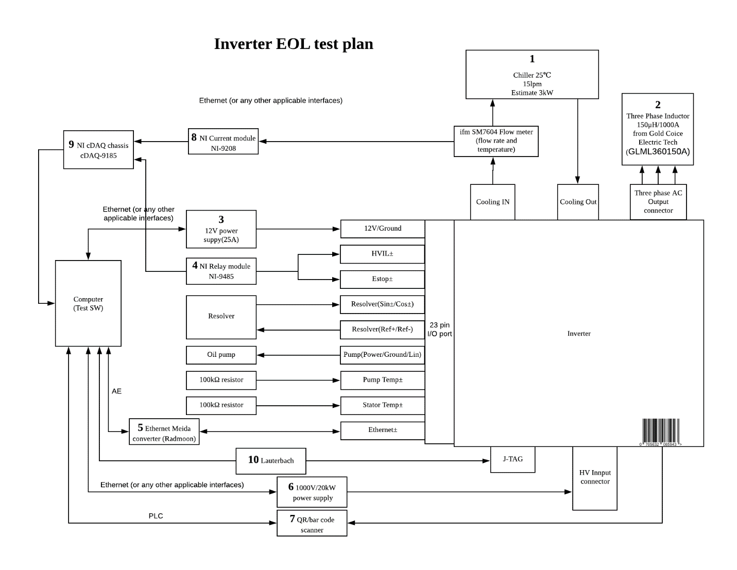

# Schematics

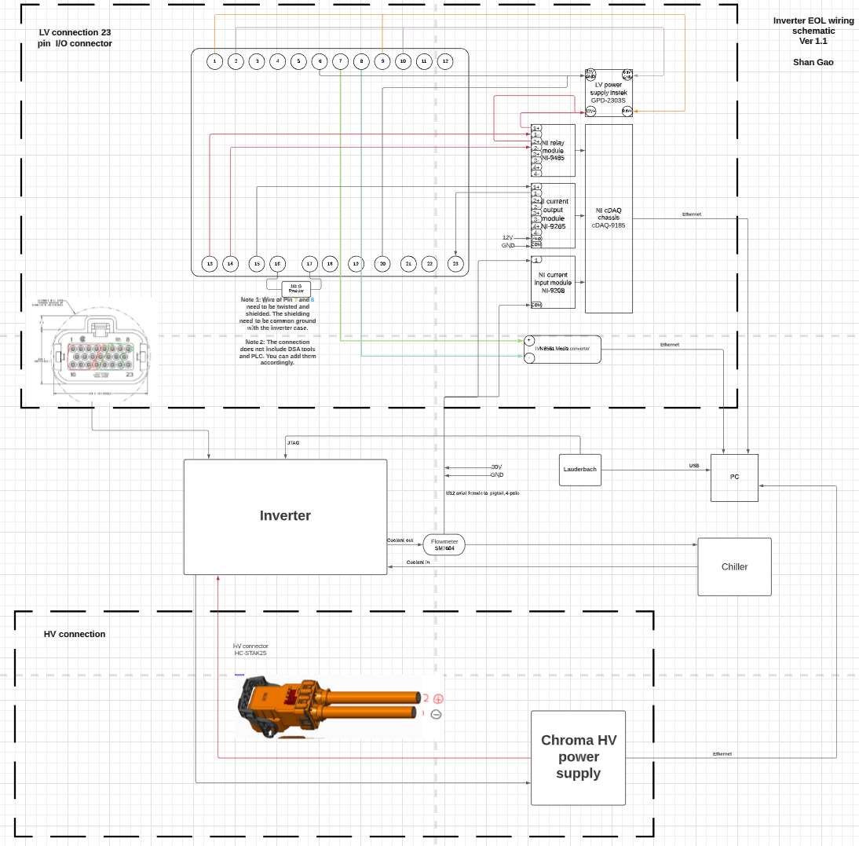

# 

# Inverter serial number Read

**Step 1**: Read inverter serial number from the pallet

Tester to scan the inverter pallet (using a PLC). Labview shall have the ability to communicate with the Allen Bradley PLC to extract the inverter serial information.

Note: Manufacturing to provide unique serial number headers to identify Front Vs Rear inverter

# MCU Software upgrade

Note: Below software/hardware will be provided by Lucid

|  |
| --- |
| **Hardware** |
| Lauterbach |
| Automotive Ethernet media converter |
|  |

|  |
| --- |
| **Software** |
| Trace-32 |
| Python-37 (latest) |
| Labview Test stand |

**Step 2.0: Pre ECU Flashing**

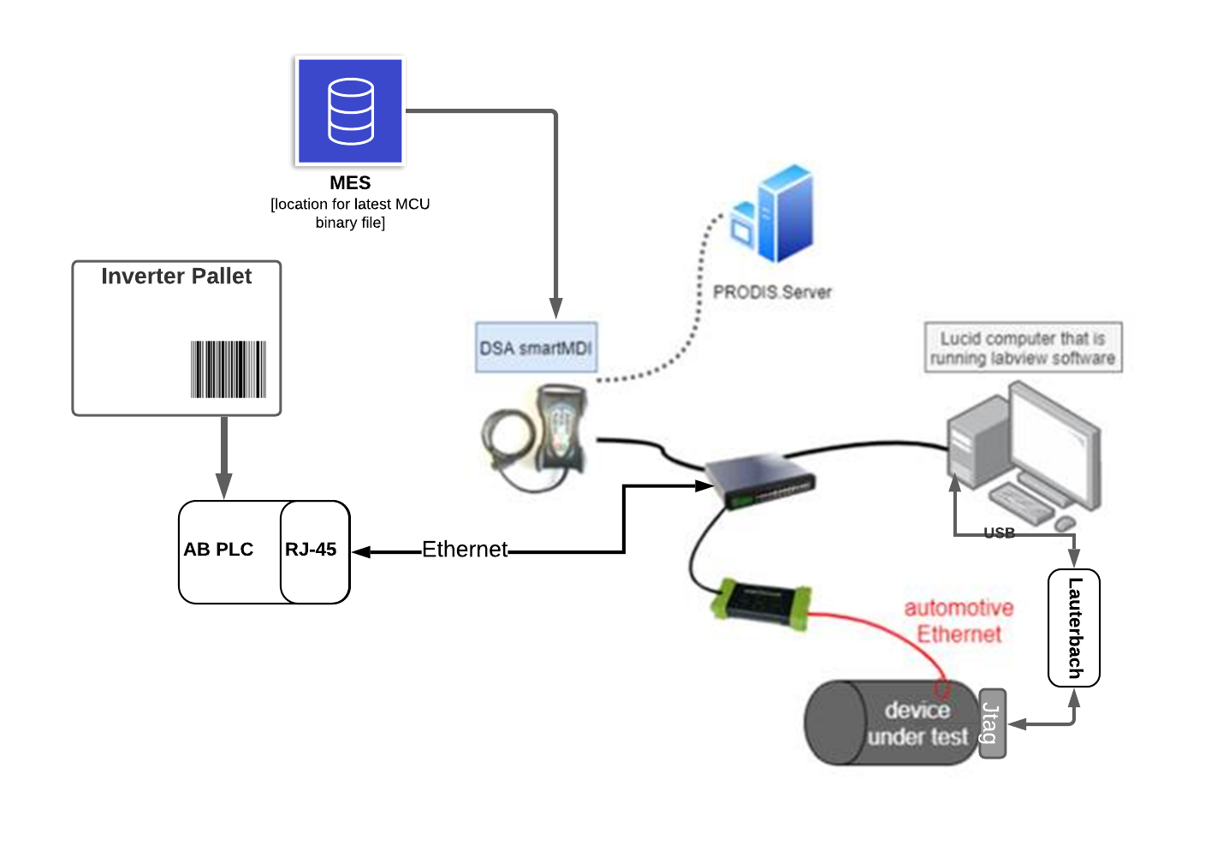

* AB-PLC scans and holds the inverter serial number from the pallet
* The inverter serial number is read by the DSA tool via proprietary DSA protocol.
* DSA tool will decode the serial number and identify if the inverter needs to be programmed as Front or Rear
* DSA tool will transmit the inverter serial number to Labview test PC.

**Step 2.1: ECU flashing**

* Connect the Lauterbach tool to MCU control board
* Connect the power adapter to the Lauterbach tool
* Connect LV harness to the inverter
* Turn on 12V to the inverter from ECU tester
* ECU flashing
  + Tester would initiate the ECU flash process.
  + This will send a trigger to DSA tool.
  + DSA tool will read the inverter serial number from Ab PLC and will decode the serial information to identify front Vs Rear to be able to pull the corresponding binaries from MES system.
* Labview will point to the corresponding folder (Front Vs Rear) to fetch necessary files.
  + Bootloader and application software can be upgraded on the ECU (Infineon TC29x) by executing a windows batch files
    - “start_5008.bat”
    - “MCUx_SetupHsmAndBootloadersAndApplication.bat”.
* Read for flash success confirmation.
* Get the flash status (pass/fail) and proceed to next steps as necessary
* Turn off 12V
* Remove Lauterbach connector from MCU once flash is successful

*** Note: 12V power supply control needs to be established from ECU tester

*** Note: x : MCU_F or MCU_R

**Step 3: FPGA flashing**

* Connect Ethernet media converter to LV harness
* Turn on 12V to the inverter
* Use DSA tool to upgrade FPGA
* Tester will initiate FPGA upgrade from Labview
* DSA will trigger the corresponding FPGA upgrade UDS routine
* After successful flash confirmation, power cycle 12V to the inverter

*** Note: FPGA flashing can be considered using DSA UDS tool chain

# Test sequence

Note: We will use Automotive Ethernet as mode of communication to send commands and receive feedback (No UDS commands required)

**Step 4**: **Software version/Hardware check**

This step will determine if the software flashed corresponds to the inverter hardware configuration (Front Vs Rear)

1. ECU tester to apply 12V to the inverter by commanding the 12V power supply
2. Display ECU software version
3. Display FPGA Verilog version
4. MCU control board revision version
5. Display “Inverter configuration”
6. Read ECU_ID ethernet message and follow below. Based on ECU_ID information reported by MCU, display if the drive unit is Front or Rear(follow below pseudo code)

* if ECU_ID & 0x3 == 1, its Front DU
* if ECU_ID & 0x3 == 2, its Rear DU
* if ECU_ID & 0x3 == 3, its Left Rear DU
* if ECU_ID & 0xC >> 2 == 1, its Full inverter (6 SiC modules)
* if ECU_ID & 0xC >> 2 == 2, its Half inverter (3 SiC modules)
* if ECU_ID & 0xF0 >> 4 == 1, its Full 4Y SiFe Motor
* if ECU_ID & 0xF0 >> 4 == 2, its Full 2Y SiFe Motor
* if ECU_ID & 0xF0 >> 4 == 3, its Full 4Y CoFe Motor

|  |  |  |  |  |  |
| --- | --- | --- | --- | --- | --- |
|  | **Ethernet PDU** | **Ethernet Msg** | **Sender** | **Receiver** | **Value** |
| 2 | MCUx_Datalogger_10 | IMCUx_SwVer | Inverter | EOL Tester |  |
| 3 | MCUx_Datalogger_PartInfo_1 | IMCUx_FpgaSwVers | Inverter | EOL Tester |  |
| 4 | MCUx_Datalogger_PartInfo_1 | IMCUx_CtrlBdRevNr | Inverter | EOL Tester |  |
| 6 | MCUx_Datalogger_4 | IMCUx_EcuId | Inverter | EOL Tester |  |

**Step 5**: **Control Valve**

*** Note: for this test, ECU Tester needs to control NI-9265 module.

1. Connect the chiller to AC outlet.
2. Set the flow rate to 12-14 lpm by controlling the flow valve through NI-9265.
3. Read feedback from the control valve to ensure the right coolant flow before proceeding to the next step.
4. Set the coolant temperature to 25C manually.
5. Read the coolant temperature feedback and ensure its accuracy by reading coolant temperature feedback on a thermocouple.

**Step-6: Control chroma DC power supply**

1. Establish communication to chroma DC power supply.
2. Command 600V DC to the power supply.
3. Read DC voltage feedback from the inverter.

|  |  |  |  |  |  |
| --- | --- | --- | --- | --- | --- |
| **Step** | **Ethernet PDU** | **Ethernet Msg** | **Sender** | **Receiver** | **Value** |
| 3 | MCUx_STS_3 | IMCUx_IvtrDcVolt | EOL Tester | Inverter | 600 |

**Step 7**: **Writing inverter serial numbers to ECUs Non volatile memory**

1. Apply 600VDC to the inverter by commanding chroma power supply
2. Set IPT_UpdSafeSt to True
3. Set the PT_STATE to “PT_Test”
4. Read the feedback from “IMCUx_St”, and ensure they match before moving to the next step.
5. Set the diagnostic mode to “WRITE_SR_NO” by writing a value of “84” to “Dyno_MCUF_SpclModReq” ethernet message.
6. Write the inverter serial number (read from the PLC) to the message “IMCUx_IvtrSrNoWrite”
7. Read the feedback from “EOL_Status” bit “1” to be True for test pass criteria
8. Do a 12v power cycle and confirm the inverter serial number is written correctly.

|  |  |  |  |  |  |  |
| --- | --- | --- | --- | --- | --- | --- |
| **Step** | **Ethernet PDU** | **Ethernet Msg** | **Sender** | **Receiver** | **Value** | **Exit criteria** |
| 2 | PT_UPDSAFEST | IPT_UpdSafeSt | EOL Tester | Inverter | 1 |  |
| 3 | PT_STATE_PDU | IPT_State | EOL Tester | Inverter | 7 |  |
| 4 | MCUF_STS_3 | IMCUx_St | Inverter | EOL Tester | 7 | Check the value to be 7 |
| 5 | Dyno_MCUF_2 | IDyno_MCUx_SpclModReq | ~~Inverter~~ EOL tester | ~~EOL tester~~ Inverter | 84 |  |
| 6 | VCU_MCUF_SRNO | IMCUF_IvtrSrNoWrite | EOL Tester | Inverter | Read from PLC |  |
| 7 |  | IMCUx_EOL_Status | Inverter | EOL Tester | Bit field:1 Value:1 | Check the value to be 1 |
| 8 | MCUF_Datalogger_PartInfo_2 | IMCUx_IvrSerlNr | Inverter | EOL Tester |  | Check the inverter sr Nr read back |

**Step 8**: **Current shunt calibration (TBD)**

**Step 9**: **Run EOL**

1. Apply DC voltage to the inverter
   1. Command 924V on Chroma power supply
   2. Read the feedback voltage from the inverter. Check this against the commanded value to proceed to the next step. Error tolerance considered is 2%.
2. Set IPT_UpdSafeSt to True
3. Test mode enabling
   1. Set the PT_STATE to “PT_Test”
   2. Read feedback from the state machine and check that against PT_Test
4. Diagnostic mode trigger through Ethernet message (No UDS necessary)
   1. Set the diagnostic mode to “CLOSED_CURR_LOOP” by writing a value of “45” to “Dyno_MCUF_SpclModReq” ethernet message.
   2. Read the feedback from “EOL_Status” bit “2” to be True for test pass criteria
5. Set the fundamental frequency
   1. Set fundamental frequency to 166 Hz.
   2. Read the motor speed feedback and check that against the commanded value.
6. Ramp current command to 350A at a ramp rate of 2000A/sec and stay there for 200s
   1. Read current feedback and run a dynamic check on the current feedback Vs current command with below criteria at steady state only
   2. Error tolerance of 5% or 5A whichever is more applicable.
7. Ramp current command to 1200A at a ramp rate of 2000A/sec and stay there for 5 sec
   1. Read current feedback and run a dynamic check on the current feedback Vs current command with below criteria at steady state only
   2. Error tolerance of 5% or 5A whichever is more applicable. Publish pass/fail criteria
8. Verify all the 6 inverter module coolant temperatures are within +/- 2 deg C threshold against each other (difference of any 2 modules should not be more than 2 deg C) at steady state. Publish pass/fail criteria.
9. Ramp the current down to 0A at 1000A/Sec
   1. Read current feedback and run a dynamic check on the current feedback Vs current command with below criteria at steady state only
   2. Error tolerance of 5% or 5A whichever is more applicable. Publish pass/fail criteria
10. 0 Hz test
    1. Wait till the coolant temperature is back to 25C
    2. Set fundamental frequency to 1.5 Hz.
    3. Read the motor speed feedback and check that against the commanded value.
    4. Ramp current command to 700A at a ramp rate of 2000A/sec and stay there for 5 sec
    5. Read current feedback and run a dynamic check on the current feedback Vs current command with below criteria at steady state only
    6. Error tolerance of 5% or 5A whichever is more applicable. Publish pass/fail criteria
11. Diagnostic mode trigger through Ethernet message (No UDS necessary)
    1. Set the diagnostic mode to “Default” by writing a value of “30” to “Dyno_MCUF_SpclModReq” ethernet message.
    2. Read the feedback from “EOL_Status” decimal value of 0.
12. Test mode disabling (default state)
    1. Set the PT_STATE to “Ready”
    2. Read feedback from the state machine
13. Command 0V on chroma power supply.

Timing diagram

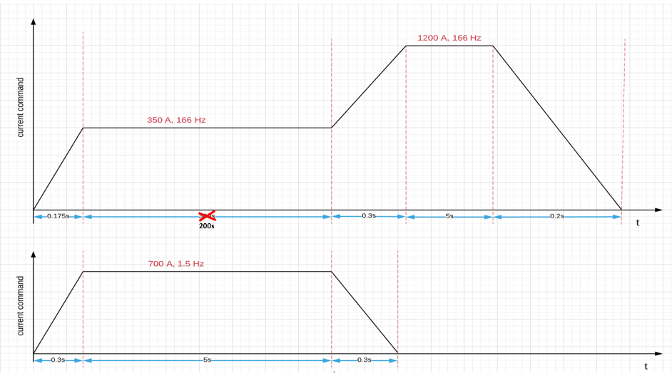

|  |  |  |  |  |  |  |
| --- | --- | --- | --- | --- | --- | --- |
| **Step** | **Ethernet PDU** | **Ethernet Msg** | **Sender** | **Receiver** | **Value** | **Exit Criteria** |
| 1 | X | X | EOL Tester | DC Chroma | 924 |  |
| MCUx_STS_3 | IMCUx_IvtrDcVolt | EOL Tester | Inverter | 924 | Within 2% of command |
| 2 | PT_UPDSAFEST | IPT_UpdSafeSt | EOL Tester | Inverter | 1 |  |
| 3 | PT_STATE_PDU | IPT_State | EOL Tester | Inverter | 7 |  |
| MCUF_STS_3 | IMCUx_St | Inverter | EOL Tester | 7 | Check the value to be “7” |
| 4 | Dyno_MCUF_2 | IDyno_MCUx_SpclModReq | Inverter | EOL Tester | 45 |  |
|  | IMCUx_EOL_Status | Inverter | EOL Tester | Bit field:2 Value:1 | Check the value to be “1” |
| 5 | Dyno_MCUx_1 | IDyno_MCUx_SpdCmd | EOL Tester | Inverter | 350 |  |
| MCUF_STS_3 | IMCUF_MotSpd | Inverter | EOL Tester | 350 | Error tolerance of 5% |
| 6 | Dyno_MCUx_1 | IDyno_MCUx_StatorIdCmd | EOL Tester | Inverter | 350 |  |
| MCUF_Datalogger_5 | IMCUF_StatorIdCmdFb | Inverter | EOL Tester | 350 | Error tolerance of 5% or 5A |
| 7 | Dyno_MCUx_1 | IDyno_MCUx_StatorIdCmd | EOL Tester | Inverter | 1200 |  |
|  | MCUF_Datalogger_5 | IMCUF_StatorIdFb | Inverter | EOL Tester | 1200 | Error tolerance of 5% or 5A |
| 8 | MCUF_IvtrModuleTemp | IMCUx_IvtrModuleTemp1 | Inverter | EOL Tester |  | +/- 2 deg C |
|  | IMCUx_IvtrModuleTemp2 | Inverter | EOL Tester |  | +/- 2 deg C |
|  | IMCUx_IvtrModuleTemp3 | Inverter | EOL Tester |  | +/- 2 deg C |
|  | IMCUx_IvtrModuleTemp4 | Inverter | EOL Tester |  | +/- 2 deg C |
|  | IMCUx_IvtrModuleTemp5 | Inverter | EOL Tester |  | +/- 2 deg C |
|  | IMCUx_IvtrModuleTemp6 | Inverter | EOL Tester |  | +/- 2 deg C |
| 9 | Dyno_MCUx_1 | IDyno_MCUx_StatorIdCmd | EOL Tester | Inverter | 0 |  |
| MCUF_Datalogger_5 | IMCUF_StatorIdFb | Inverter | EOL Tester | 0 | Error tolerance of 5% or 5A |
| 10 | Dyno_MCUx_1 | IDyno_MCUx_SpdCmd | EOL Tester | Inverter | 3.144 |  |
|  | MCUF_STS_3 | IMCUF_MotSpd | Inverter | EOL Tester | 3.144 | Error tolerance of 5% |
|  | Dyno_MCUx_1 | IDyno_MCUx_StatorIdCmd | EOL Tester | Inverter | 700 |  |
|  | MCUF_Datalogger_5 | IMCUF_StatorIdFb | Inverter | EOL Tester | 700 | Error tolerance of 5% or 5A |
| 10 | Dyno_MCUF_2 | IDyno_MCUx_SpclModReq | Inverter | EOL Tester | 30 |  |
|  | IMCUx_EOL_Status | Inverter | EOL Tester | Value:0 | Check the value to be “0” |
| 11 | PT_STATE_PDU | IPT_State | EOL Tester | Inverter | 1 |  |
|  | MCUF_STS_3 | IMCUx_St | Inverter | EOL Tester | 1 | Check the value to be “1” |

**Step 10**: **Data Analysis**

Save test results to MES system (using infrastructure provided by DSA)